MYSQL ASSIGNMENT 2- QUERYING DATA
Sona Varghese

1. Distinct Values:
⦿ a query to retrieve distinct salaries from the Employees table.
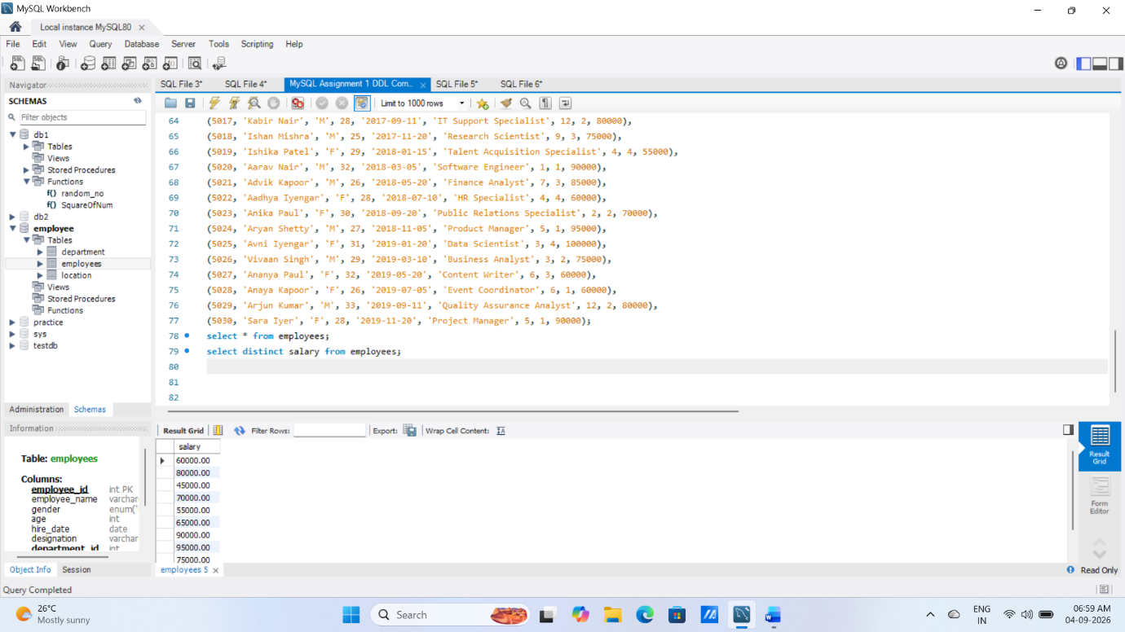
2. Alias (AS):
⦿ Provide aliases for the "age" and "salary" columns as "Employee_Age" and
"Employee_Salary", respectively.
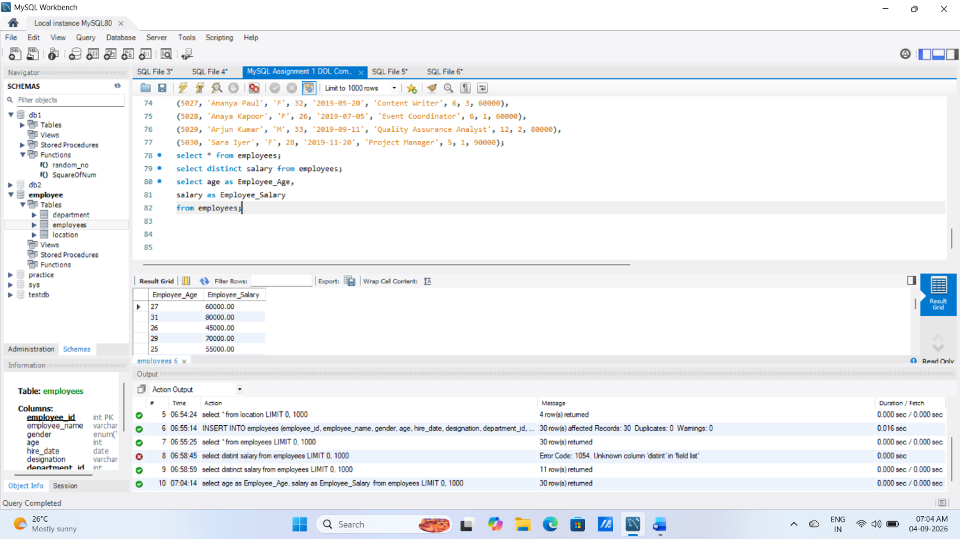

3. Where Clause & Operators:
⦿ Retrieve employees with a salary greater than ₹50000 and hired before
2016-01-01.
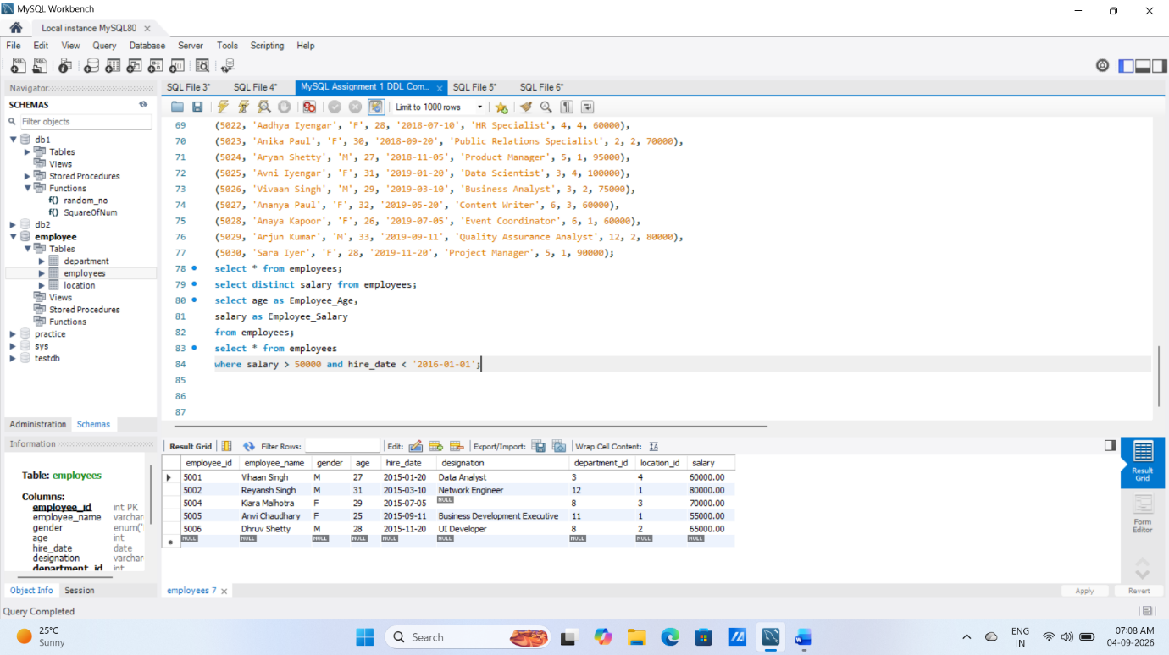
⦿ Find the employee whose designation is missing and fill it with "Data
Scientist".
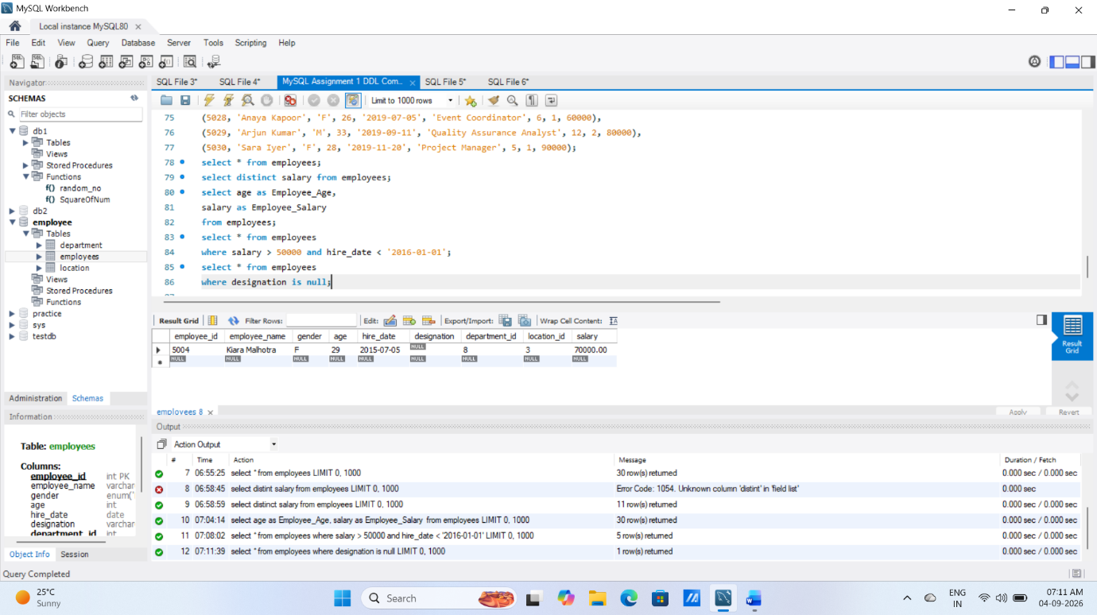

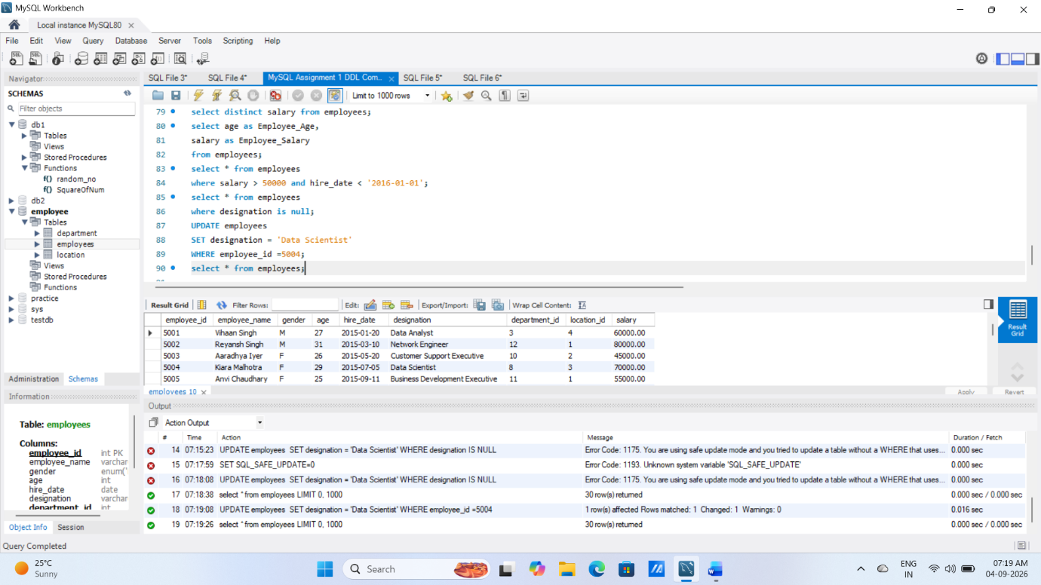

Sorting and Grouping Data:
1. ORDER BY:
⦿ Find employees sorted by department ID in ascending order and salary in
descending order.
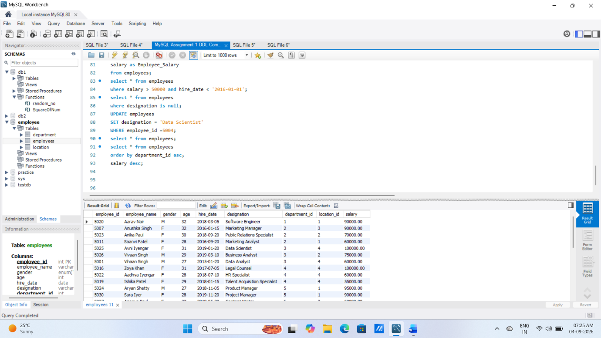
2. LIMIT:
⦿ Display the first 5 employees hired in the year 2018.
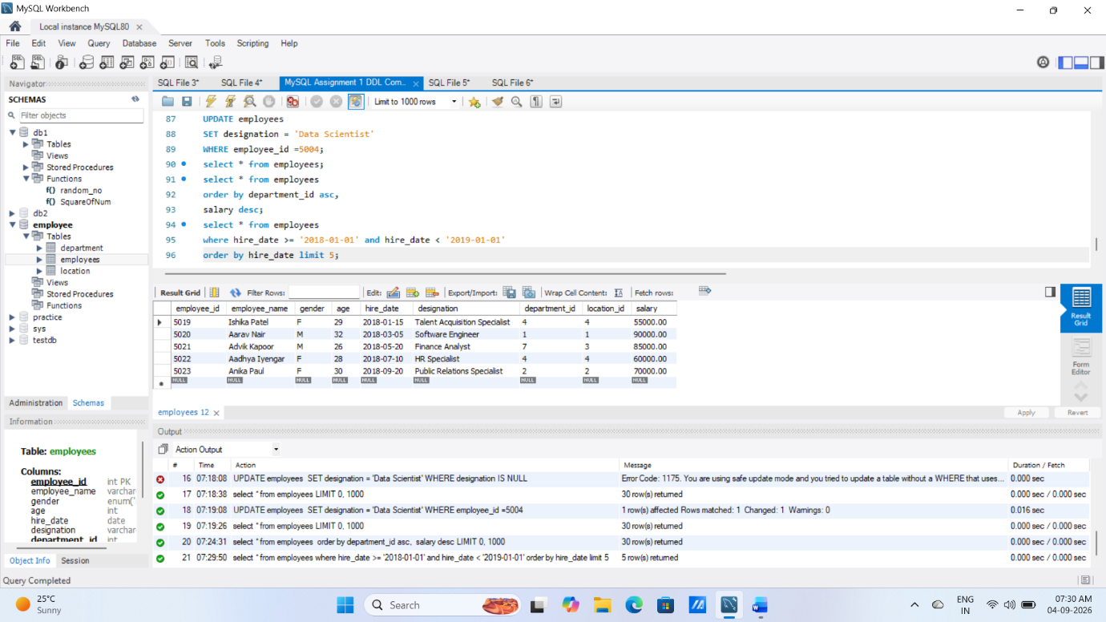
3. Aggregate Functions:
⦿ Calculate the sum of all salaries in the Finance department.
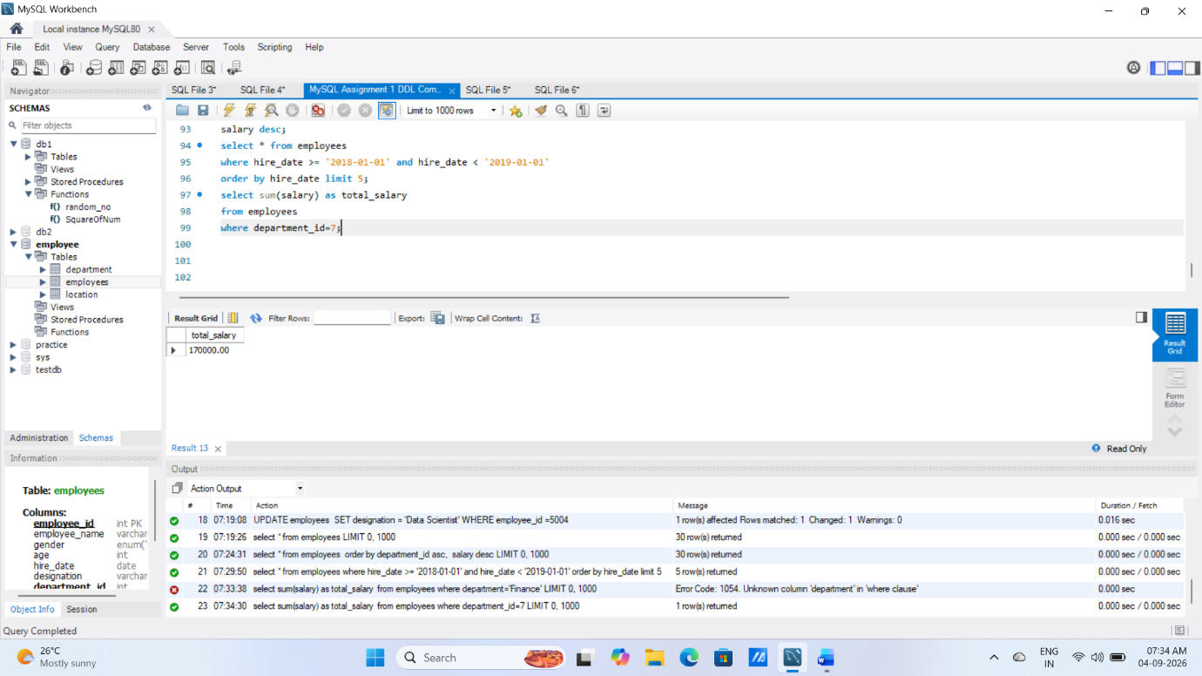
⦿ Find the minimum age among all employees.
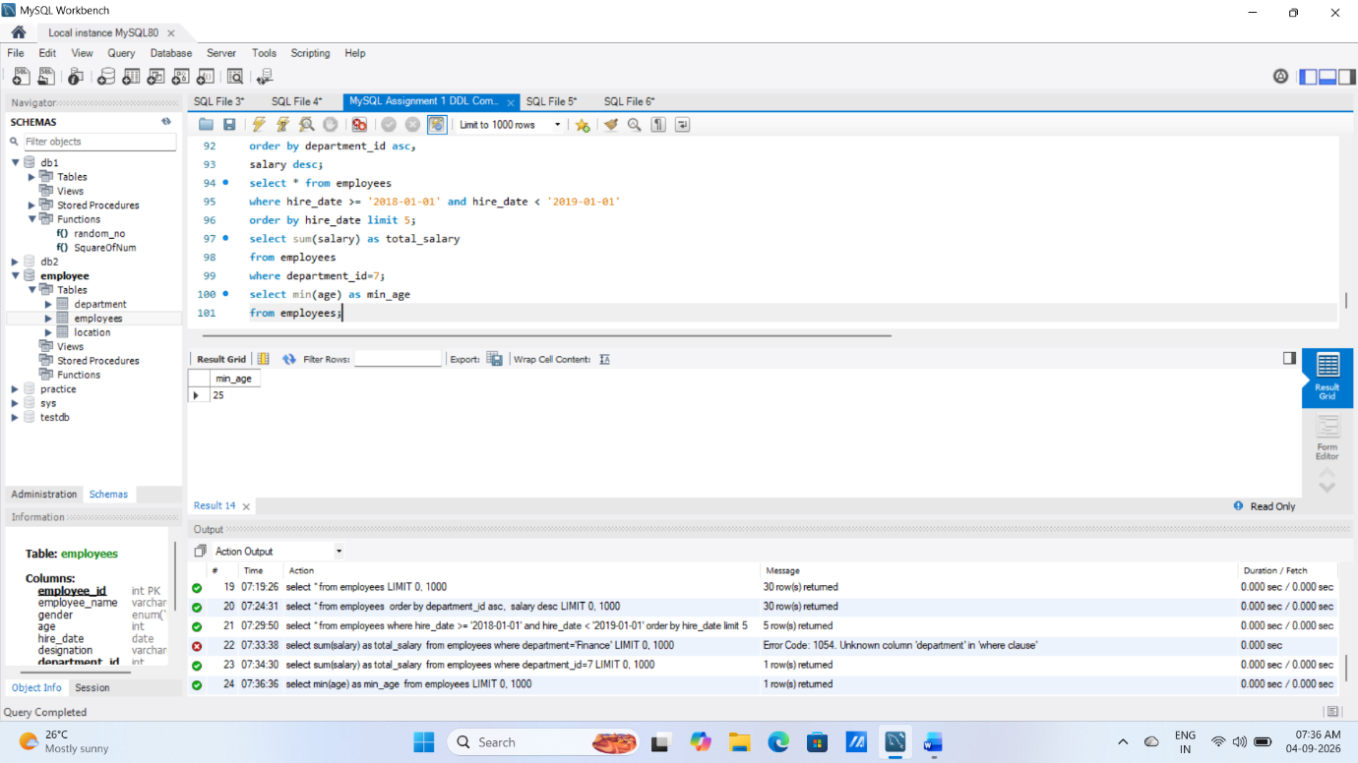

4. GROUP BY:
⦿ List the maximum salary for each location.
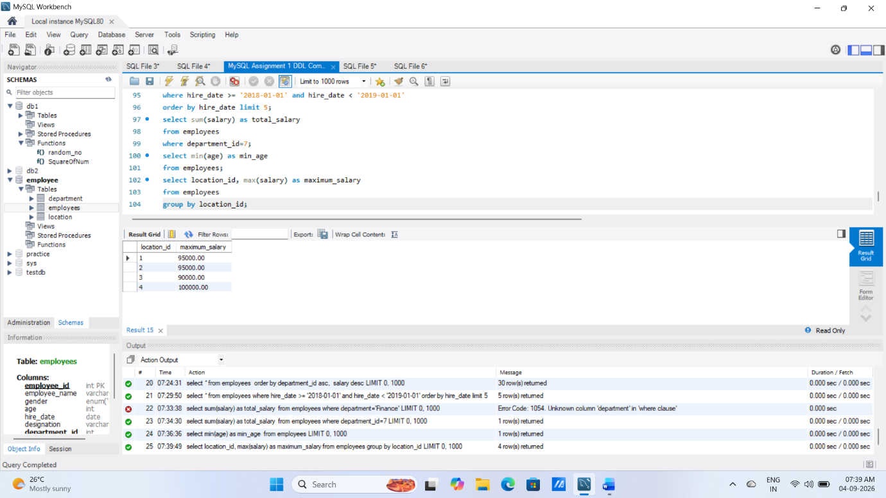
⦿ Calculate the average salary for each designation containing the word
'Analyst'.
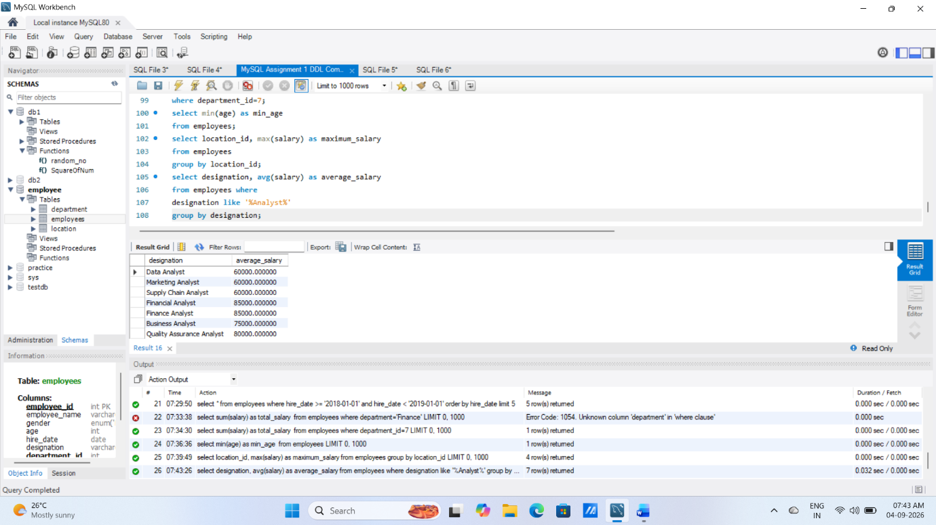
5. HAVING:
⦿ Find departments with less than 3 employees.
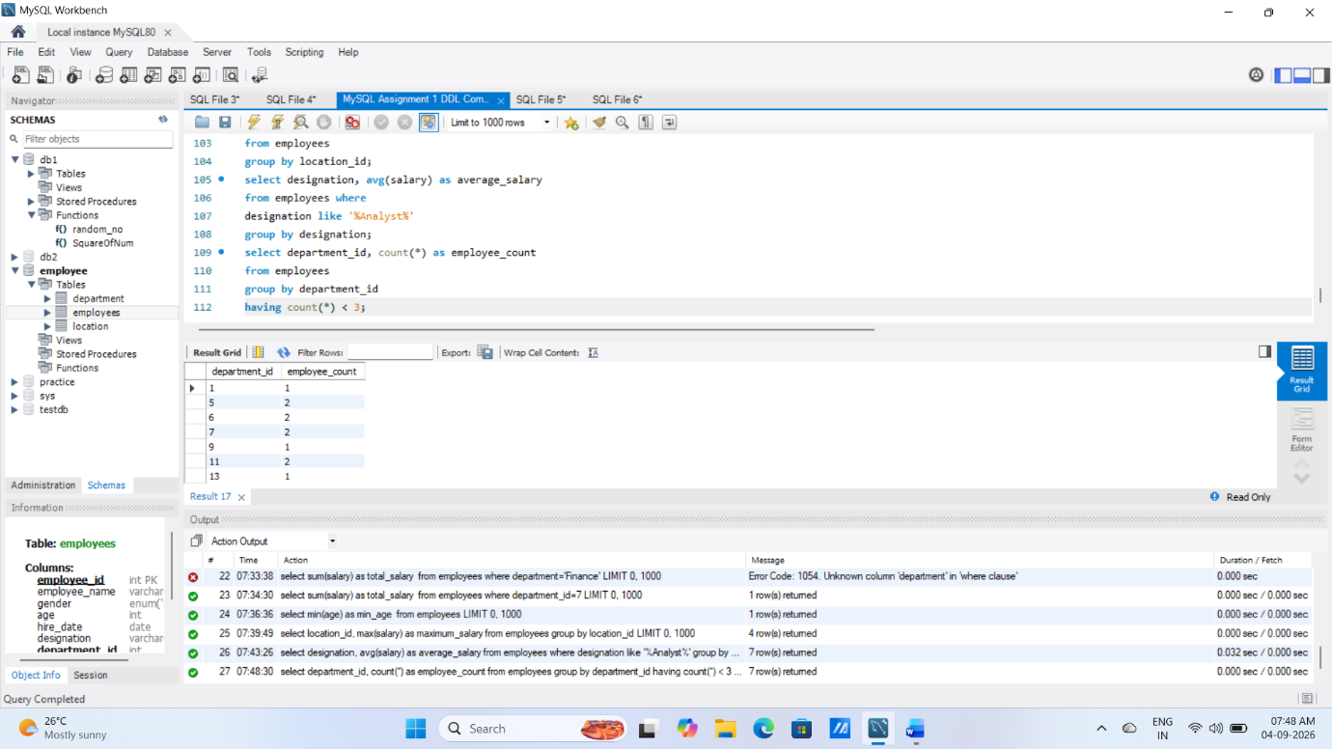
⦿ Find locations with female employees whose average age is below 30.
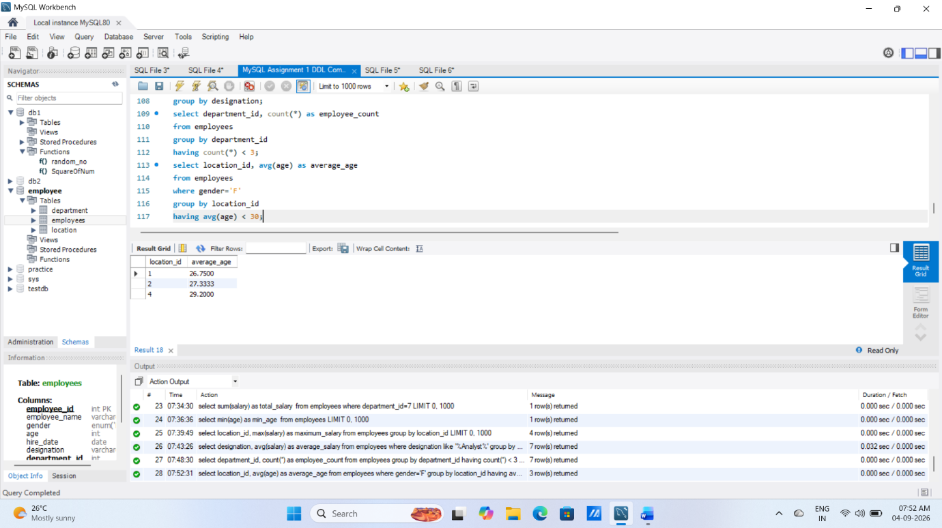
Joins:
1. Inner Join:

⦿ List employee names, their designations, and department names where
employees are assigned to a department.
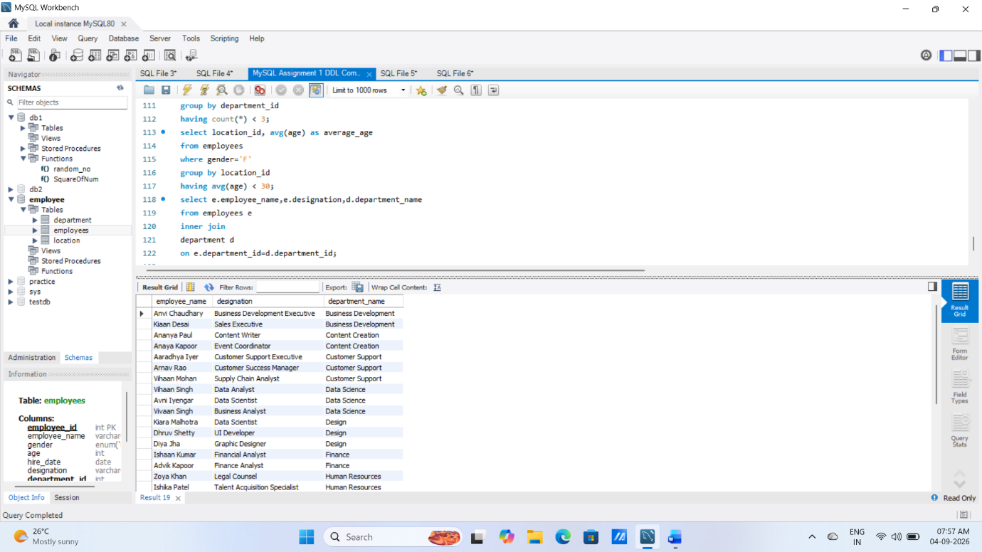

2. Left Join:
⦿ List all departments along with the total number of employees in each
department, including departments with no employees.
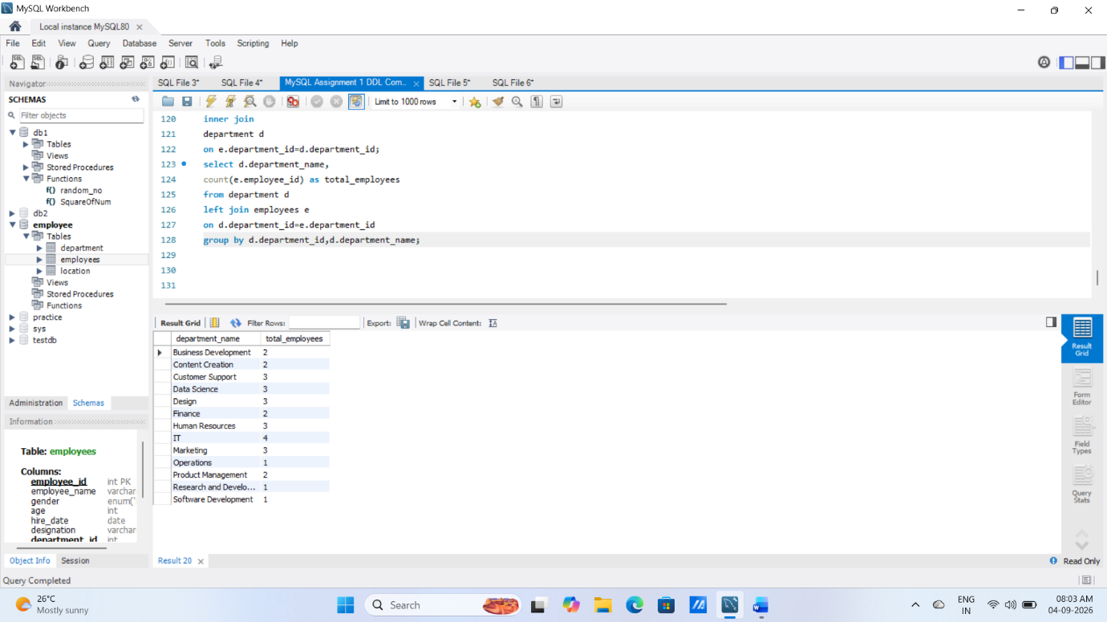

3. Right Join:
⦿ Display all locations along with the names of employees assigned to each
location. If no employees are assigned to a location, display NULL for
employee name.
